Excel Practice Part II Formulas and Functions

I.
1. Here is a slightly challenging equation to program into Excel. You can try to enter the entire equation into one formula, or divide it into subparts in several columns and then combine into the whole solution in the last column.

The standard deviation of a sample of n results is calculated as:

$s={\left(\frac{1}{n−1}\sum{(x_{i}−X})^{2}\right)}^{1/2}$ where s is the standard deviation, x_{i} are the results and X is the mean. Calculate the mean and the standard deviation for the sample: 10.1, 10.5, 9.9, 9.5, 10.6, 9.4, 11.5, 9.5, 9.5, 10.0, 9.5.

2. Repeat using the AVERAGE and STDDEV functions in Excel to check your answers.

II.
1. Set up a worksheet for the calculation of the equilibrium constant, K_{eq}, and free energy, ΔG, from the percentages of components A and B in a two-component system like you see below.

The formulas were created with Equation Editor (Insert | Object…) and the chemical equilibrium equation was created in ChemSketch. Make sure you can reproduce them.

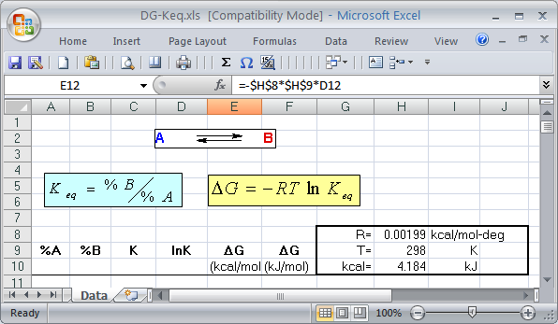

2. In cell A12, enter 99.9, then in the two cells below it enter 99 and 98. Select the latter two numbers as a range. Autofill the series 97, 96, 95,…3, 2, 1. Complete the column of %A by entering the values 0.1 and 0.001 at the bottom.

3. Enter the appropriate formulas in the cells B12:E12 that are necessary to calculate the quantity in the header row 9. (Instead of the formulas you see in the illustration below, you will see the results of the calculation.) Copy the formula cells to all the rows below it (rows 13-113).

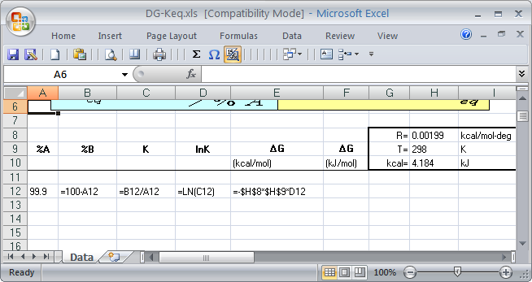

4. Format the numbers in columns C-E for 6 decimal places.

5. In cell F12, enter a formula for the conversion of ΔG in kcal to kJ using an absolute cell reference. Copy it to the cells below it.

6. Observe the effect on the values in column E when you change the numeric entry for the temperature from 298 to 350 K. Select the cells with the new values and copy them. Click in cell J12 and choose Paste Special…. | Values. Click in one of the cells to observe the effect.

Change the temperature in H9 back to 298 K.

7. Of course, you could have combined all of these column calculations into a single calculation. Insert a column between E and F. (Note that the formulas in column F adjust accordingly. What happens if you move the cell containing the absolute reference?) Write a single formula for calculating ΔG from only %A and any needed constants. If you've done it correctly, it should give the same answer as cell E12.

III.

Suppose you want to calculate the grade averages for students in a laboratory class. For those students with perfect attendance, the lowest grade will be dropped. If one grade is missing, the average grade will be determined without dropping a grade.

1. Calculate the total points for reports for each student.

2. Use the IF function to calculate the average grade according to the criteria above. (It is easier to perform intermediate calculations first to check how your formulas work.) Use the COUNT function within the IF function. Build in flexibility to the spreadsheet. For example, you might want to re-calculate every time a new report grade is inserted into the spreadsheet. Don’t use the AVERAGE function for this problem.

rev. 10/22/08

