Introduction to Excel

Part I
Instructions are for MS Excel 2007.

A spreadsheet is a collection of data entries: text, numbers, or formulas, arranged in columns and rows. The data can be displayed in a variety of ways, manipulated and analyzed.

A workbook is a collection of worksheets (spreadsheets). Each worksheet contains 1048576 rows and 16384 columns (A through XFD). A cell is the intersection of a lettered column and a numbered row, e.g. A1. The active cell is highlighted. In the spreadsheet below, the active cell is B9.

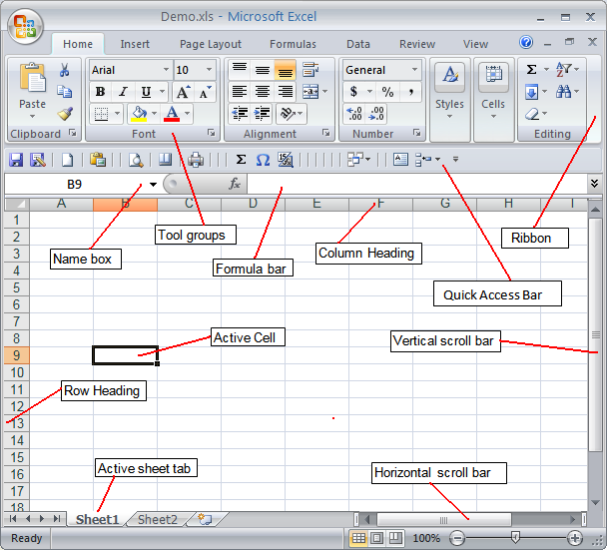

Excel is a Windows application so many of the menu items and functions are the same as in Word and so should be familiar to you. Copy/cutting/pasting, and linking/embedding objects entail the same procedures as in Word.

- Learn the names and functions of the various parts of the Excel window.
- Become familiar with the contents of the Microsoft Office Button.
- Experiment with the items on the Ribbon.
- Learn how to access and use Excel Help.
- Learn how to navigate the worksheet using: Ctrl Home; End ←↓↑→; Name box; Page Up/Down; Vertical/Horizontal scroll bars.
- Learn how to select a range of cells in various ways (click and drag; click-shift-click; name box).
- Learn how to move and to copy cell contents.
- Learn the various options under Paste Special…
- Express numbers in various formats and with the proper number of significant digits.
To enter numbers in scientific notation (as distinct from formatting a number to display in scientific notation), type: 6.63E-34 or =6.63*10^-34
- Practice linking and embedding equations (Equation Editor) and various images in Excel worksheets and charts.
- Naming worksheets and changing their order in a workbook.

Data

Manual entry
Left-click a cell with the mouse or move around the sheet with the keyboard direction arrows ←↓↑→ to select a cell.

Enter data manually by typing in the cell. Complete the entry by pressing one of the arrow keys depending on what direction you want to go (left, right, up, down) or by clicking the mouse in another cell. You can also press [Enter]. (You can change the resulting directional movement of pressing [Enter] by choosing MSO Button | Excel Options | Advanced and checking "After pressing Enter, move selection…".)

From Word tables
Word tables resemble spreadsheets (and you can do some limited spreadsheet actions in Word tables) and the data in a table can be pasted into Excel.

Select and copy [^C] all the cells in the Word table that you want to copy to Excel. In the spreadsheet, select the cell that will be the upper left cell of the pasted Word data. Paste [^V] the table contents into the spreadsheet. You may have to convert the text to columns (see below).

From text
Depending on how the data is delimited, the data is pasted into Excel either in a range of cells like table data, or all in one cell or column.

- If the data is tab-delimited, it can be copied and pasted just as for tables, above.
- If the data is delimited with almost any character, such as a comma or a period, or is fixed-width, and has line breaks at the end of each row, the delimited data for each row is entered into one cell in a column. However, this single column can be converted in Excel to multiple columns of data.
- Select the column of data to be converted.
- Choose Data tab | Data Tools | Text to Columns… from the tool group.
- Check the appropriate choices to finish the conversion.

What happens if you select and copy a range of data from Excel and paste it into Word?

Editing Data

- Edit data before entering it by using the backspace key.
- After the data has been entered, select a cell, press the F2 key and edit the cell contents.
- Double-click in the cell. (Check option MSO Button | Excel Options | Advanced | Allow Editing directly in cells.)
- You can also select a cell and then edit the contents by clicking the mouse cursor in the formula bar.
- Or you can simply type over the existing cell contents.

Formatting Data

To apply formatting such as boldface, italics, etc. to cell contents, activate a cell. Use the mouse to select the content you want to format in the formula bar. Or, double-click in the cell and select the content you want to format. Apply the formatting by choosing a tool button or the appropriate Format tool. Some formatting is lost when data is copied from Word to Excel.

Ranges

A cell range is one cell or a rectangular block of two or more cells. The range is described by the cell references (addresses) of the upper left and the bottom right cells. Select a range by
- typing the cell references separated by a colon in the Name box; or
- clicking in a cell and dragging the mouse over the range area; or
- clicking a cell and, while pressing the [Shift] key, pressing an arrow key; or
- click-shift-click

Change the size of an empty range by grabbing and moving the "active handle".

Columns and Rows

Learn how to:
- Select entire columns; select entire rows; select non-contiguous columns/rows/ranges
- Insert and delete entire columns; insert and delete entire rows.
- Increase or decrease column width and row height.
- Move an entire column or row

Moving Data

Select a cell or range that you want to move.

- From the Home tab, choose the Cut tool. Select a cell or range to move to. From the Home tab, choose Paste; or
- Use the keyboard shortcuts: Cut (^X) and Paste (^V); or
- With the mouse cursor, position the cursor on the border of the selection so that the cursor changes to an arrow. Drag the selection to the new position.

Use the ALT key while dragging to move data from one worksheet to another in the same workbook.

Copying Data

Select a cell or range that you want to copy.

- From the Home tab, choose the Copy tool. Select a cell or range to move to. From the Home tab, choose Paste; or
- Use the keyboard shortcuts: Copy (^C) and Paste (^V); or
- With the mouse cursor, position the cursor on the square on the lower right corner of the border of the selection so that the cursor changes to a black cross. Drag the selection to any adjacent position(s) in the spreadsheet; or
- With the mouse cursor, position the cursor on the border of the selection so that the cursor changes to an arrow. While pressing [Ctrl], drag the selection to the new position.

Explore the variations using Paste Special…(Formulas, Values)

Go to Excel Practice I

rev. 3/26/09

