Excel to HTML

You can convert all or parts of an Excel workbook into an HTML file. With the workbook open, from the Office button choose Save as | Other Formats. If your workbook consists of several sheets, the HTML version will open showing the sheet that is visible when you save the workbook.

In the dialog box, accept the default file name or choose a new one. For Save as type, choose Web Page (*.htm, *.html). Do not choose Single File Web Page which will only work in Internet Explorer.

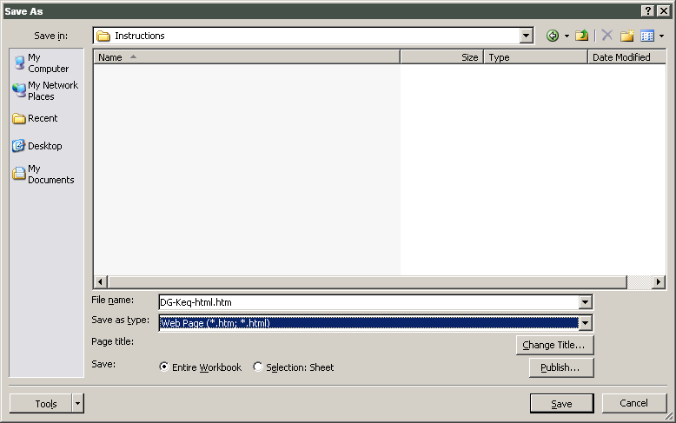

To choose a title for the browser title bar, incorporated in the <TITLE> tag, click the Change Title… button.

If you choose Save: Entire Workbook, all sheets and charts in the workbook are saved in several HTML files. You can save just the active sheet of a workbook (a chart or other worksheet) by clicking the Selection: button

I. Click the Save button. Notice in the Excel window title bar the new .htm file name replaces the .xls file name. The entire workbook is saved and can be viewed in a web browser. What other files/folders have been created during the save?

Open the file in both Firefox (or Netscape) and Internet Explorer (from the file directory, drag the file name into an open browser window).

- Do you notice any differences in the appearance of the page in the two browsers?
- Make a couple of changes to the .htm file while it is open in Excel. Save the changed file. Reload (Refresh) in a browser. Do you see the changes?

In each of the browser windows, select page areas that have cells and the various types of embedded objects (charts, equations, text boxes, etc.). It may not be obvious that you have selected an object. In Netscape/Firefox, right-click on an object and choose View from the pop-up menu. You can see the object in the new window. Copy the selection and paste it into a Word document. How do the parts of the web page appear in the Word page? Any differences between browser sources?

II. When you are ready to publish your Excel workbook on your web page, FTP the workbook file you saved (the new .htm file) and the new directory that was created concurrently. The new directory contains images and objects that are associated with the workbook. They must be uploaded to your site.

Create a hyperlink to the new .htm file from your project page or other page.

If you make any changes to your workbook, then delete all files and directories associated with the older version before uploading and linking to the newer version.

III. You can also use the “Publish” feature of the Excel-to-HTML dialog window to make a few choices and to view your page immediately as a local file.

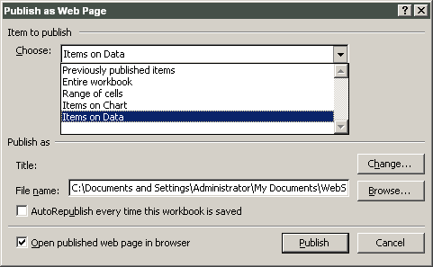

Explore the drop-down menu under Choose: (The items will be different depending on the names of your worksheets in the workbook –try to have examples of embedded charts and charts as sheets). If you want the new page to open immediately check the box Open published web page in browser.

Click on the Publish button.

If you try these exercises multiple times, you realize the Publish dialog box shows previously published items.

Excel Help is a big help.

If you look at the Page Source for your page in a browser, you'll see that the html programming is very complicated and would be very difficult to edit.

Exercises

Download the DG-Keq-html.xls file. Open it in Excel. Save it as DG-Keq.htm.

Open the htm file in a browser. Right-click on the equations and text boxes to confirm that they are images.

Starting in the upper left, select the columns of data. You will also be selecting the other objects. Copy. Open a new sheet in Excel and Paste. What do you observe?

Repeat the selecting and copying above. This time, choose Paste Special… | Text. What is the difference?

Spring, 2008

