Deleting, Formatting and Recovering Files

Deleting (erasing) files

When you delete a file in Windows, the file is moved to the Recycle Bin. If you open the Recycle Bin, you will see it there. The file can be moved out of the Recycle Bin either by dragging it to a location or Restoring it to the old location. If you Empty the Recycle Bin, for all practical purposes, the file is then deleted.

If you delete a file from a diskette or flash drive, the file does not go to the Recycle Bin.

However, deleting or emptying the Recycle Bin does not actually erase the file. Rather, the file name is changed by inserting a special character at the beginning of the file name and the operating system can no longer detect it. They are not destroyed when first deleted, and he chances of file recovery are excellent if no files have been written to the disk since the deletion. As new files are created and other files are modified, the disk space occupied by the deleted file is over-written by the changes. Eventually, it becomes so corrupted it cannot be saved.

Formatting drives

Formatting a drive does a very good job of erasing files. If you are going to get rid of a diskette, flash drive, or computer hard drive, you can format it and be sure that your files are erased for all but the most determined effort to recover bits of them.

Insert the diskette or flash drive. For a flash drive, follow the additional directions below before proceeding.

For flash drives only: Right-click the MyComputer icon on the Desktop or Start menu. Choose Manage. In the left pane, choose Device Manager. In the right pane, click on Disk Drives and double-click the flash drive (USB device). Choose the Policies tab and check the “Optimize for Performance” setting. Click OK.

Open MyComputer. Right-click the drive letter for the device you want to format. In the pop-up menu, choose Format…. If you want a low-level format, check the Quick Format box. If you want the full format, leave the box unchecked. Click Start. When the warning box appears, click OK. When the format is complete, click OK. Click Close.

Recovering deleted files

The freeware program I use for deleted file recovery is PC Inspector File Recovery. There are many others. These programs can "look behind the scenes" to see if files still exist and if so, attempt to recover them. Businesses that specialize in "data disaster" recovery use tools such as this.

After running the program, the results are shown in Figure 1 on the next page. All the files shown have been "deleted" and do not show up in Windows file listing.

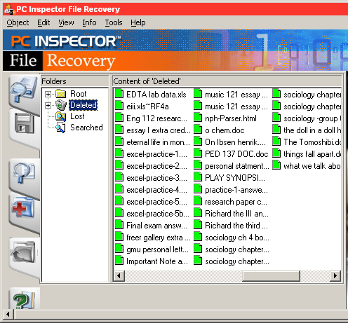

Quick format

After using the Quick Format option in Windows, the files still have not been erased on either a diskette or a flash drive. However, the FAT (file allocation table) has been deleted. The operating system thus cannot read the list of files on the disk. It might be more difficult to recover these “cluster” files.
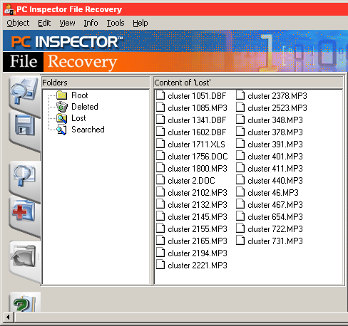

Full format

In the Full format mode (Quick format box is not checked), the files really are gone on a diskette! (Well, not really, but only intensive data recovery efforts will bring them back.) A flash drive cannot be full-formatted – at least not by the method used for diskettes. If you want to be sure there is no trace of files on either a flash drive or a diskette, use a Wipe program.)

